Buy File Automation SOP

Created by: Ben Dinhofer | Supervised by: Matt Widjaja | Updated on: July 20th 2022

If you are having trouble running the script and cannot find an answer within the SOP, please contact Matt Widjaja for support!

Sections

Empower Outlook Folder Setup 1

Script Setup 4

Running the script 7

Terminal messages and how to deal with them 7

# Empower Outlook Folder Setup

Note: Even if you already have an Empower folder setup, follow along to properly determine your folder path for the next steps.

1. Click “File” in the top left on your Outlook page

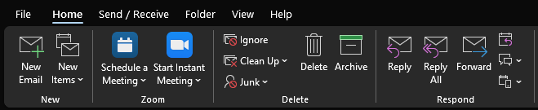

1. Click “Manage Rules & Alerts”

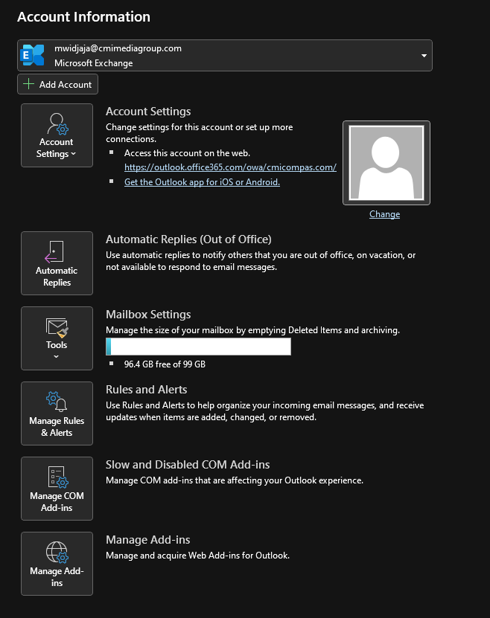

1. Select “New Rule…”

1. Select “Move messages from someone to a folder”, then select “people or public group” down below

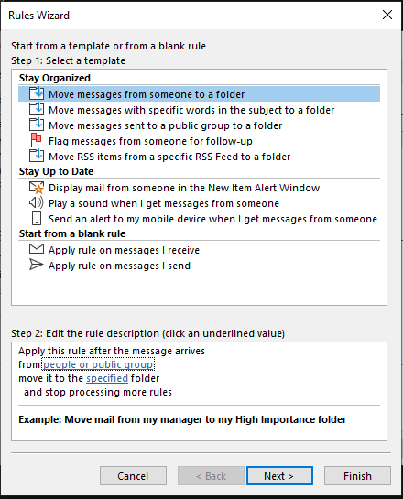

1. In the new window, search “Empower” then double click “Empower” so it appears in the bottom window and click “Ok”

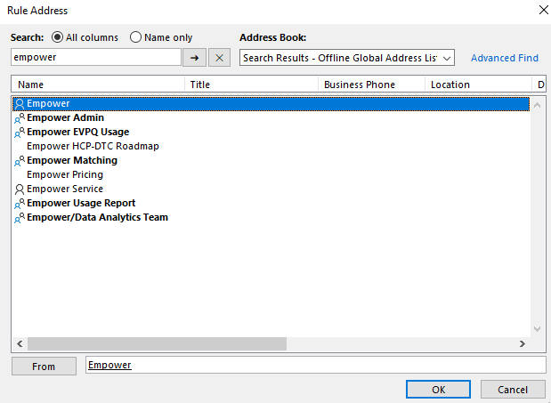

1. Now select “specified folder” to open this window. Here you can create a new folder or select an existing folder to move Empower pull requests to, please ensure no other emails other than Empower pull requests can appear in the folder.

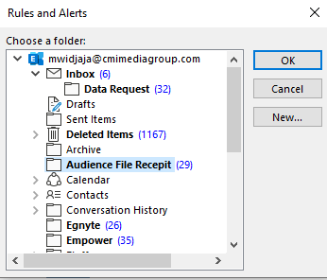

The Outlook folder paths of some of the folders displayed here would be:

Data Request: mwidjaja@cmimediagroup.com/Inbox/Data Request

Empower: mwidjaja@cmimediagroup.com/Empower

1. Click through the Rules Wizard until you reach this page, select “Run this rule now on messages already in ‘Inbox’” then click Finish.

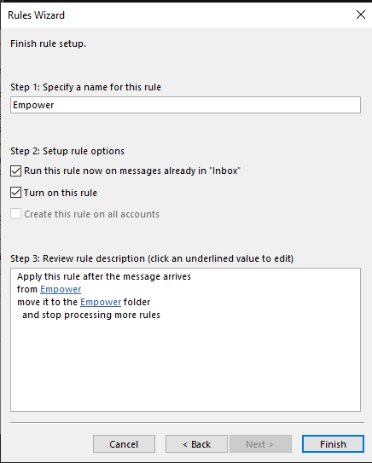

# Script Setup

1. Firstly, you should make sure that all the files for this script are saved locally on your computer, not in the shared drive. You should be using the script locally on your computer.
2. After your training, you will receive a zip file which when extracted will contain these three files, along with this SOP. Make sure all files are present before proceeding.

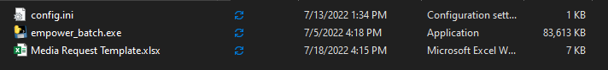

1. Now that you have your files, you will need to open the config.ini file with Notepad

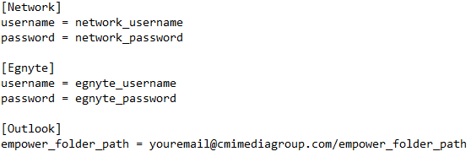

1. Fill in your Egnyte/network details as well as the folder path to your Empower folder in Outlook.
   1. Your network details refer to your Okta login
   2. Please note that when you change your network password, the change must be reflected in this file.
2. If you have already requested that your media team fill in these request template for you, you may run the program, otherwise you will need to go through each request in Outlook and fill in the details into the “Media Request Template.xlsx” file. The next section will cover the request template file and how to fill it out based on the media team’s request.

Media Request Template

In this section, we will cover all the columns in the request template and how to fill them out according to the media team’s request.

1. Brand, Client, and Target List ID

For these first three columns, looking at this example request we can identify the client is “Genentech USA”, the brand is “Venclexta”, and the target list ID is “1117bbdc”.

However, the actual pull in Empower looks like this so while the client and target list ID were accurate, the request would fail due to there being no match on the brand so here we would change the brand to “Venclexta CLL”.



As an analyst, while this program is meant to automate the majority of the request, you should always have familiarity with your brands in Empower to prevent these early hiccups from hindering the process. If there is an issue with the brand/client not matching, this will be addressed in the error handling section.

1. Vehicle Name, Channel, reachable_or_active

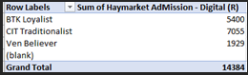

For these three fields, always defer to the pivot table over anything else in the request email. Here, the vehicle is “Haymarket Admission”, the channel is “Digital” and reachable_or_active is “reachable” while if it was (A) then it would be “active”

1. main_email, cc_emails, me_flag

Fill in these three fields with the [contact sheet](https://compas1.sharepoint.com/:x:/s/CIA-EmpowerResourcesandContactList/EYNyoIEBaL9JkxHP33ebK-ABHaGK6v06YOn1607FCfifHw?e=QXsZ8B). If the supplier should receive ME numbers, set the me_flag to 1, if not then set it to 0.

1. Egnyte directory

Open [Egnyte](cmicompas.egnyte.com) in the browser, navigate to the folder that the buy files will be uploaded into (create it if it doesn’t already exist) and copy the URL in the egnyte_directory column. Note: The URL should point directly to the vehicle name folder within the “buy file” folder for the specified target list and brad, not the brand/target list folder.

Example:

This link is incorrect as it points to the “Buy” Folder within the “Tremfya Derm 1d6f68c3 June 2022” folder.

<https://cmicompas.egnyte.com/app/index.do#storage/files/1/Shared/Documents/ByDoctor/ByDWork/Janssen/Biotech/Tremfya%20Derm/Tremfya%20Derm%201d6f68c3%20June%202022/Buy>

While this link points to the vehicle name (Medscape Custome Targeted Media) folder within the “Buy” folder which is in the “Tremfya Derm 1d6f68c3 June 2022” folder.

[https://cmicompas.egnyte.com/app/index.do#storage/files/1/Shared/Documents/ByDoctor/ByDWork/Janssen/Biotech/Tremfya%20Derm/Tremfya%20Derm%201d6f68c3%20June%202022/Buy/Medscape%20Custom%20Targeted%20Media](https://cmicompas.egnyte.com/app/index.do%23storage/files/1/Shared/Documents/ByDoctor/ByDWork/Janssen/Biotech/Tremfya%20Derm/Tremfya%20Derm%201d6f68c3%20June%202022/Buy/Medscape%20Custom%20Targeted%20Media)

1. Segments and total_count columns
   1. Fill in the total_count column with the total record count for the specific request. If this does not match the record count that is seen in Empower it will cause an error. (This will be covered in more detail later)
   2. Fill out the SegmentTitle1 with the name of the field you want to filter on.
      1. This can be found in the pivot table media sends
      2. Similar to the brand/client name, this must be filled out exactly as it appears in Empower. If there is an issue with a segment not matching, this will be addressed in the error handling section.
   3. Fill out the necessary segment1_nameX columns according to the pivot table. You can add as many segment names as needed.
   4. Repeat steps b. and c. for all segment fields present in the request, the script can handle as many segments as necessary as long as the naming convention is followed.
2. Processed and file_name
   1. The “processed” column is used to keep track of which requests have and have not been processed yet where a “1” denotes that the request has been processed. While adding new segments, just leave this column untouched unless you want to rerun a request then you can clear the cell.
   2. Additionally, the last column (Scroll all the way to the right to see it), file_name, will only be filled in once a request has been successfully processed by the program. It will be filled in with the file name of the request that has been processed.

The screen shot below shows an example of what the Media Request Template should look like when filled out correctly:

# Running the script

1. Ensure that you have saved the request file and CLOSED out of it.
2. Ensure that you have properly filled out the login info as well as the Outlook path in the config file.
3. Double click the empower_batch.exe to run it
   1. This will open a command line terminal
   2. It will look blank for 15 seconds to a minute (It will vary every time you open it) as it loads up the environment
   3. When the program runs, it will open a new Chrome instance and messages will begin to appear which will inform you of the status of the process.
   4. If any instructions pop up, follow them exactly. (In the next section we will cover all possible messages and how to handle them)
   5. Eventually the program will say it has completed all requests and tell you to shut it off
   6. Check your email draft folder for the request emails, don’t forget to QA before sending them off!

# Terminal messages and how to deal with them

1. Empower Export Errors
   1. The most common and simple type of error message to handle will be when you have entered something into the excel template file wrong or some other circumstance that makes the name of something in Empower different from what you expect.
   2. For example, if, on the excel template sheet I wrote “Tremfya Der” instead of “Tremfya Derm” I will see this error message appear in the terminal:

1. The program tells you it could not find your input (in this case the brand name “Tremfya Der”) and then moves onto processing the next request you set up.
2. When it has finished processing every request, it will tell you to please address the issues that it found.
   1. To do this follow these steps:
      1. Open the excel template file.
      2. make the necessary changes.
      3. Save and close the file
      4. Hit enter to rerun the program.
   2. This will not rerun any requests that have been successfully processed.
   3. When a request is successfully processed the “Processed” column, at the right end of the excel template sheet, will change to a 1 in each row that was processed successfully.
3. Continuing with the above example, when I make the changes to the excel template file and hit enter on the terminal, it will only process request #1 as request #2 was already processed successfully.

1. You can see here that the program ignores request #2 as it has already been successfully processed, and now that request #1 has been processed, it prompts you to hit enter to close the program.
2. The columns in the excel template sheet that may have error messages that can be handled following these steps include, brand, client, target_list_id, placement_id, vehicle_name, channel, Egnyte_directory, total_count, the SegmentTitleX columns and the segment_nameX columns.
3. Config File Errors:
   1. There can also be errors in your initial set up of the script.
   2. If your network/Egnyte username and password are incorrect you will get an error message that looks like this:

* 1. There may also be an error if the outlook folder path to the Empower Outlook folder is invalid. This error will return this message:

* 1. To handle each of these errors simply edit the credentials entered in the config file, save it and close, then rerun the program.

1. Unknown Errors/Bugs.
   1. Rarely, the program may return an unknown error message. Many of the times that this happens, simply closing the program and rerunning it may fix it. Try closing it and rerunning it once or twice before you deem that it did not work.
   2. If rerunning it does not work, look at the request in more detail. Try to understand if there is anything unusual or unique about how this request should be processed. Unfortunately, if this happens, the request will have to be completed manually.